|  |  |
| --- | --- |
| **Ex. No: 8** | Building a REST API with Express, Node, and MongoDB |
| **9.10.2023** |

**Aim:**

## To Build a REST API with Express, Node, and MongoDB

**Program:**

Server.js

const express = require('express')

const app = express()

const mongoose = require('mongoose')

mongoose.connect('mongodb://localhost:27017/student', { useNewUrlParser: true })

const db = mongoose.connection

db.on('error', (error) => console.error(error))

db.once('open', () => console.log('Connected to Database'))

app.use(express.json())

const studentSchema = new mongoose.Schema({

name: String,

age: Number,

grade: String,

});

const Student = mongoose.model('Student', studentSchema);

app.get('/students', async (req, res) => {

try {

const students = await Student.find();

res.json(students);

} catch (error) {

res.status(500).json({ error: error.message });

}

});

app.post('/students', async (req, res) => {

const { name, age, grade } = req.body;

try {

const newStudent = new Student({ name, age, grade });

await newStudent.save();

res.json(newStudent);

} catch (error) {

res.status(500).json({ error: error.message });

}

});

app.put('/students/:id', async (req, res) => {

const { id } = req.params;

const { name, age, grade } = req.body;

try {

const updatedStudent = await Student.findByIdAndUpdate(

id,

{ name, age, grade },

{ new: true } // Return the updated document

);

if (!updatedStudent) {

return res.status(404).json({ error: 'Student not found' });

}

res.json(updatedStudent);

} catch (error) {

res.status(500).json({ error: error.message });

}

});

app.delete('/students/:id', async (req, res) => {

const { id } = req.params;

try {

const deletedStudent = await Student.findByIdAndDelete(id);

if (!deletedStudent) {

return res.status(404).json({ error: 'Student not found' });

}

res.json({ message: 'Student deleted successfully' });

} catch (error) {

res.status(500).json({ error: error.message });

}

});

app.listen(3000, () => console.log('Server Started'))

**Output:**

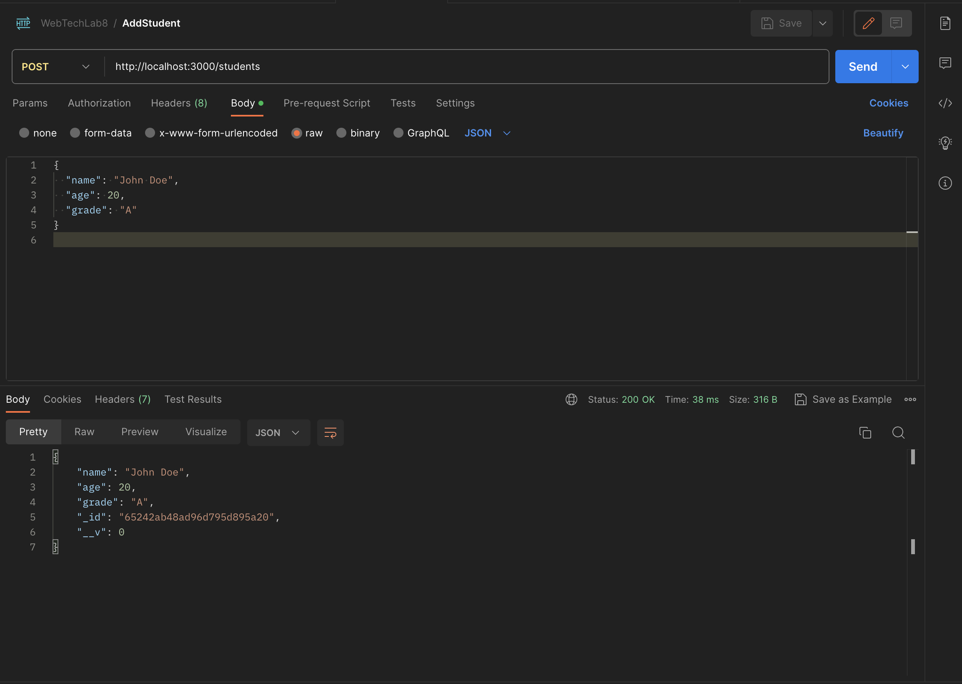

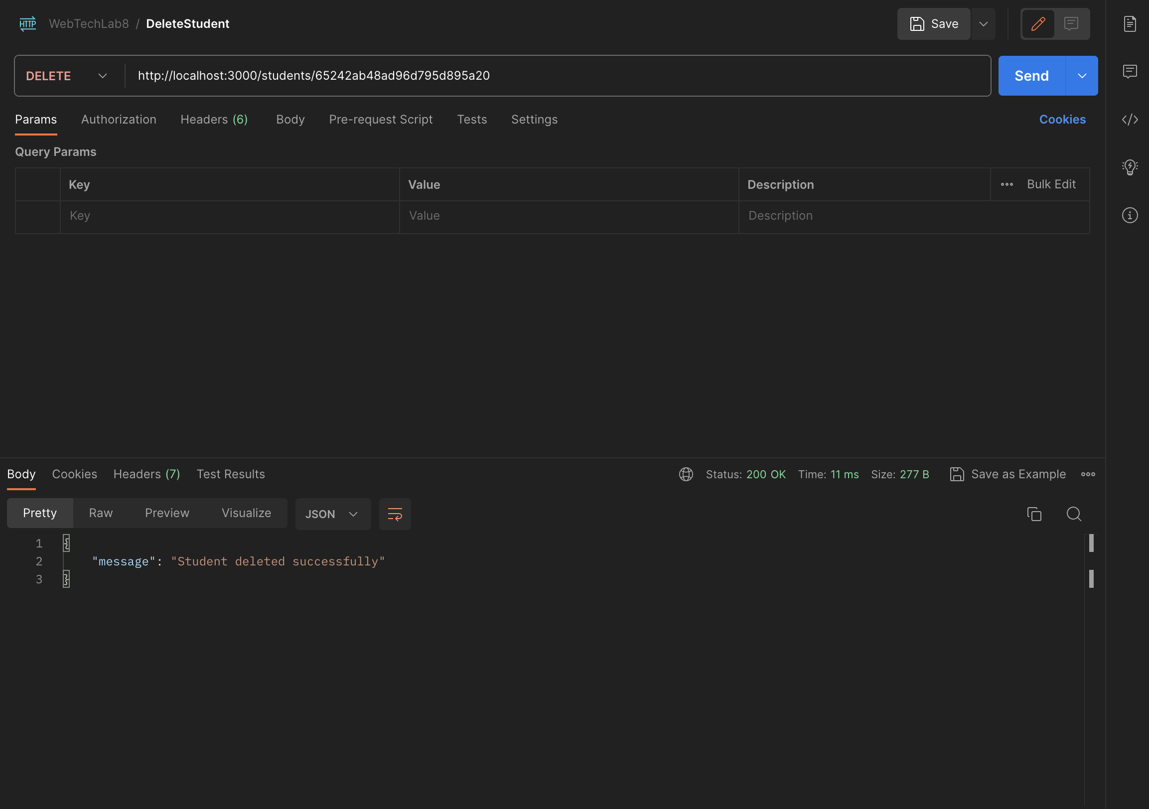

**Result:**

Successfully built a REST API with Express, Node, and MongoDB